Register Class Diagram

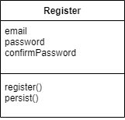
This is a class diagram for our registration component. It pertains to ST-0, “As a user, I need to be able to create an account to access private rooms.” This component has three fields: email, password, and confirmPassword. Email and password are self-explanatory. ConfirmPassword is used to confirm that the user has typed the password they intended by having them retype it and compare it to the password field. If the comparison returns true, the register method passes the data through the API and python backend methods to be stored in the database. The persist method is used to locally store the user’s email for easier login in the future.

Login Sequence Diagram

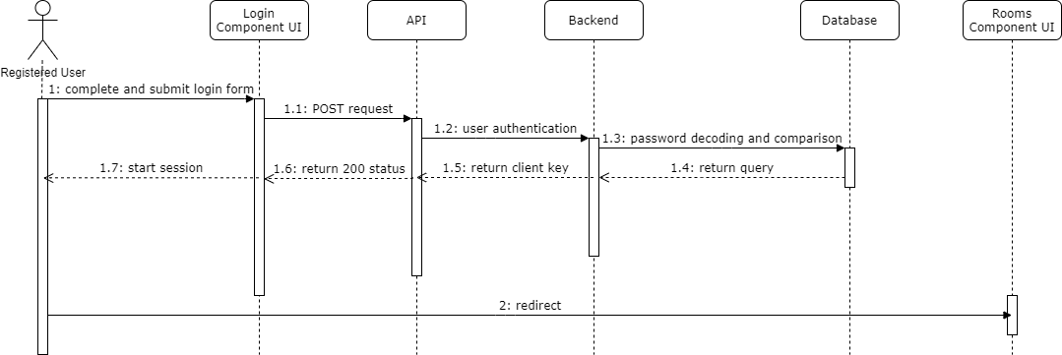
This is a sequence diagram for our login component. It pertains to ST-1, “As a user, I need to be able to log in to my account.” This component takes email and password inputs that registered users enter into the login form. Then a post request is made to the API which calls a login authentication method in the backend. The method queries the users table in our database to validate the data passed. If successful, the query returns the user’s client key and starts a Vue session. Finally, the user is redirected to the Rooms page on success.

